Welsh National Opera Design Challenge 2022-2023

Information pack for tutors

Index

Page 2 What is the Design Challenge?
Who is it for?
When does it run?
Who judges the entries?
What do I need to do?
Page 3 What support will I get?
What does the winner receive?
How do I get involved?
When are the deadlines?
Page 4 The Brief
Example Set Boxes
Page 6 Background to Welsh National Opera
Page 7 Judging Criteria
Page 9 Terms and Conditions

What is the Design Challenge?
The Welsh National Opera Design challenge is an opportunity for students in colleges and universities to apply their skills and creativity to a set design task set by industry professionals working for the Welsh National Opera and Cardiff Theatrical Services.

Who is it for?
Applicants can be from any subject discipline and need no prior knowledge or experience of set design or theatre. They just need to follow the brief and develop a response showing their creative interpretation of a Director’s Vision.

When does it run?
The project will launch in January 2023 and the closing date for submissions is Monday 27th March 2023.

Who judges the entries?
Entries to the challenge will be judged by industry professionals from Welsh National Opera and Cardiff Theatrical Services, including members of the technical and design teams. Judging will take place in May 2023.

What do I need to do?
Tutors from any subject area are invited to work with their students on this challenge. This could be within the curriculum, or extra-curricular. This tutor pack contains a brief for the students to follow. Tutors will also be provided with a brief synopsis to this year’s opera as well as Director’s Visions to inspire the creative responses.
This year, there will be two categories for submissions, and entrants can choose their preferred category depending on their interest.
Category 1: A design presented in 2D (for example sketches, notebooks, mood boards, photographs of model set boxes, screenshots of 3D designs)
Category 2: Immersive Technologies (for example games, VR/AR etc)
Entries will be welcomed as paper-based or digital entries but should be 2D or digital (i.e. not a 3D built set). These can be as creative as the student wishes them to be, as WNO are looking for new ideas, designs and originality. We do not expect every college to have set design courses, so we encourage any discipline to get involved whether that be graphic design, technical theatre, illustration etc
Entries can be submitted electronically or by post by Monday 27th March 2023 to Welsh National Opera.

What support will I get?
In addition to this tutor pack, there is a film available on WNO’s website https://www.youtube.com/watch?v=aQXIlNztnTM.
Tutors are invited to send any requests for support calls with WNO to jo.esposti@ccskills.org.uk. Visits may also be possible.

What does the winner receive?
As we know that entries will be from students from a multitude of disciplines, we would like to tailor the prize to the individual winner based on their career interests.

How do I get involved?
To register your interest and receive updates, please email jo.esposti@ccskills.org.uk

When are the deadlines?
The deadline for submissions is Monday 27th March 2023.

The Brief

Students are asked to design a set for the opera La Bohème.
The design should be 2-dimensional (paper-based or digital), and should focus on an original, creative response to the synopsis and Director’s Visions (below).
Applicants do not need to have any experience of opera or set design, but must be prepared to create a design that could be scaled up to a set box (dimensions: 1:25)
We would like to see the following areas have been considered:
- If any parts of the set move, how do they move?
- Where would the lights need to be to highlight key points of the design?
- How could the set be constructed and deconstructed if it is large?
There is no right, or wrong answer to the brief. We are interested in seeing the creative responses from all applicants.

Example Set Boxes

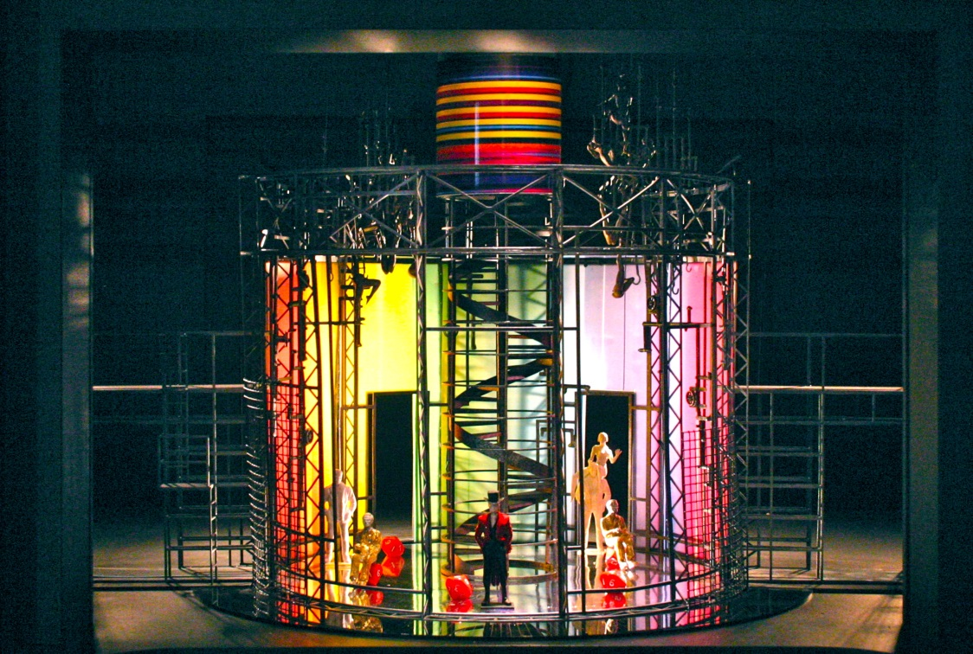
Here are a few examples of set designs and boxes which have been created by professionals. This is purely to give an idea of what we are looking for, we appreciate that the designs may not have this level of detail.

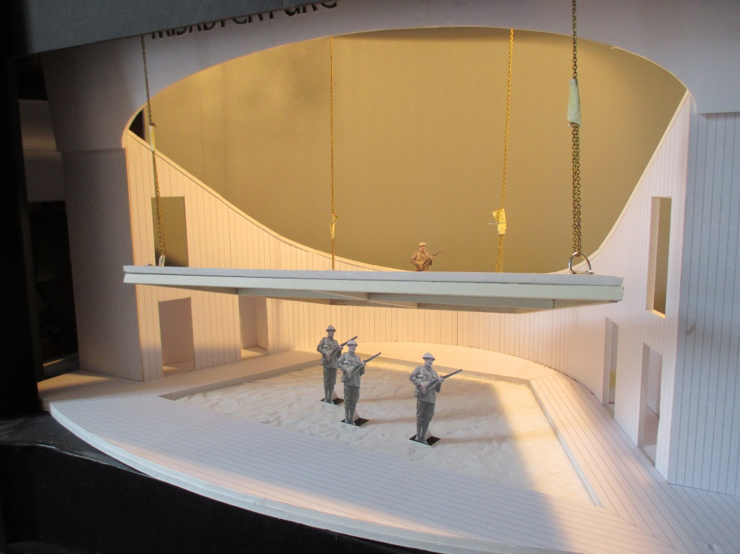

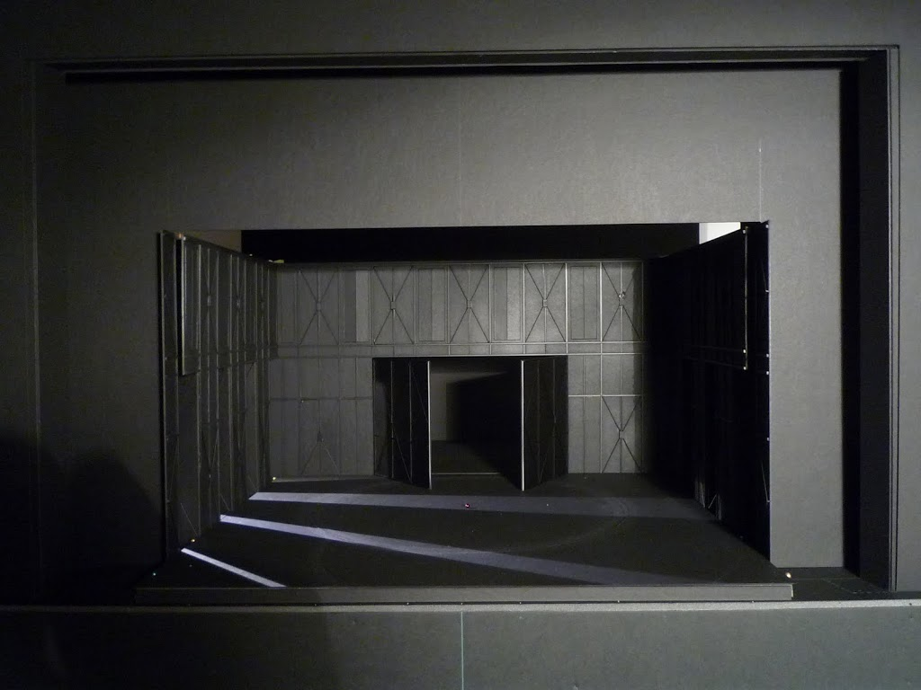

Appendix:

Background to Welsh National Opera

Welsh National Opera is Europe’s largest touring company. Annually, WNO gives more than 120 performances of eight main stage operas to a combined audience of around 150,000 people. It gives regular performances in Cardiff (Wales Millennium Centre) and Llandudno (Venue Cymru) in Wales, and Bristol (The Bristol Hippodrome), Birmingham (Birmingham Hippodrome), Liverpool (Liverpool Empire Theatre), Milton Keynes (Milton Keynes Theatre), Oxford (New Theatre Oxford), Plymouth (The Lyric, Theatre Royal Plymouth), and Southampton (Mayflower Theatre) in England.
A designer is usually asked to produce a set-model no later than six months before an opening night. From this model the Production Manager calculates if a design can actually work, how feasible it is and what changes may need to be made for the variety of venues WNO visits. The model is also used to present to other members of the company. The Publications and Marketing Departments need to see it so that programmes and publicity material correspond accurately with new productions. Singers and performers also see it, usually on the first day of rehearsals, so they are able to place themselves, artistically, in the production.
Theatrically reproducing the detail for a set from the model box is the next task; firstly the set-model is dissected and costed. The technical team must then work very closely with builders, suppliers, making and technical departments ensuring everything is completed ready for the beginning of the rehearsal period. Co-ordinating all these elements in preparation for a first night takes many months of intense work.

Judging Criteria

The designs submitted on 27th March 2023 will be judged on their concept and initial design process.
Judging will give equal measure to the research and design experimentation process, as well as the technical practicality of the design. There will be three areas that each design will be judged on.
- An informed design process: showing related research into the theatrical form, opera text, and context of the director’s vision.

- Creative interpretation: showing that the theatrical form has been explored and experimented with, and that the design is relevant to a contemporary audience.
- Technical and staging practicality: a basic overview of construction, build and operation has been considered and explained.

An informed design
- Has shown a coherent journey between research, experimentation and final design.
- Has shown research related to the chosen director’s vision.
- An understanding has been shown of set design formats, and the chosen approach has taken into consideration other design elements such as lighting, sound and costume.

Creative interpretation
- Director’s vision has been translated into the physical stage space.
- The design process has experimented with proscenium arch possibilities.
- Evidence that contemporary theatre design has been explored.

Technical and staging practicality
- Consideration has been made to any practicalities for actors and stage crew during the running of a performance.

Presentation of work
The design can be presented in any format (according to the categories listed above) as long as it accurately reflects the vision and concept of the process, and the below criteria are adhered to:
- Up to 800 words or a 90 second video pitch of the design. It should reference your research and the materials that are being presented, to help demonstrate how you have responded to the brief and the director’s vision, including:
- Why you picked that specific director’s vision.
- Notes on how it would be constructed, including ensuring the creation of a safe working environment for technical crews and performers.

- A range of process drawings, from research, experimentation to final design, either in hard copy or digital.

- Applicants should also deliver a mood board to demonstrate the feel and style of the production design.

All sent items need to be able to fit into an A3 envelope or on a memory stick. This is to allow for easy storage and for items to be sent back.

Please send to the following address:
Design Challenge 2022-2023
Welsh National Opera
Wales Millennium Centre
Bute Place
Cardiff
CF10 5AL

Terms and Conditions
- The closing date for paper / digital based designs will be 27th March 2023.

- Only entries by individuals will be considered. Any group entries will not be considered.

- Any contact details supplied will be used solely for administering the competition and will not be published or provided to any third party without the explicit prior permission of the entrant.
- By submitting an entry for this competition, the entrant agrees to Welsh National Opera having exclusive licence to use entries for all media for the purposes of administering, performing and promoting the competition including unlimited limitation streaming on the internet.

- By submitting an entry for the competition, the entrant warrants and represents that the work is their original work and does not infringe the copyright or any other right of any other person.

- By submitting an entry to the competition, the entrant will ensure a completed media permission form is completed by any models used within the design representation.

- The competition is not open to employees of, or close relatives of employees of, Welsh National Opera.

- The decision as to winners of the competition is final and in the absolute discretion of the Welsh National Opera panel. No correspondence will be entered into.

- Winners will be contacted via their College by email, telephone or by mail. Where a winner cannot be contacted after reasonable attempts have been made, Welsh National Opera reserves the right to offer the prize to another entry.

- Welsh National Opera takes no responsibility for late or lost entries due to the postal service or any other event beyond the control of Welsh National Opera.

- Welsh National Opera reserves the right to cancel this competition without notice at any stage if it is deemed necessary in the absolute discretion of Welsh National Opera or where events beyond its control prevent the proper administration of the competition.

- By submitting an entry for this competition, the entrant indicates their unconditional assent to these terms and conditions and agrees to be bound by them.

- This competition is administered by Welsh National Opera in partnership with Creative & Cultural Skills.

